TECHNIQUE 2: RUNNING A DOCKER CONTAINER AS DAEMON.

DOCKER DAEMON:

It is a process that runs in the bacground of the host machine rather than under the direct control of the user.
It listens for docker API requests and manages Docker objects such as docker images, containers, networks and volumes.

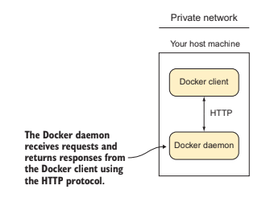

WHY RUN A CONTAINER AS A DAEMON?

- Keep conatiners running in the background even after closing the terminal.
- Multiple containers can be run at the same time without having to keep them up and running in separate terminals.

PROBLEM:

To run Docker container in the background as a service.

SOLUTION:

Use the -d flag to the docker run command.

Example: $ sudo docker run -d <imgname>:<tagname>

STEPS

Step 1: Create a Dockerfile.

Dockerfile is a text document that contains all the commands a user could call on the command line to assemble an image.

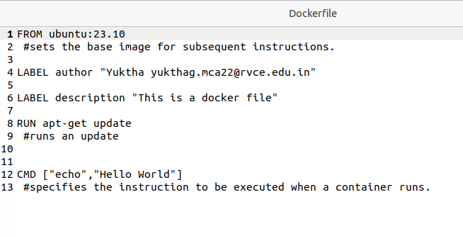

Step 2: Build the Dockerfile.

To build the Dockerfile, move to the directory in which the Dockerfile is present and check if the Dockerfile is present using the ls or cat command.

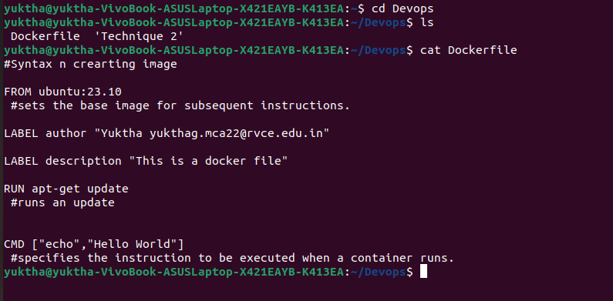

Command:

$ sudo docker build -t <imgname>:<tagname> .

Here,
- the -t is a flag that is used to specify the tag name.
- (.) is used at the end of the command to specify the current working directory.

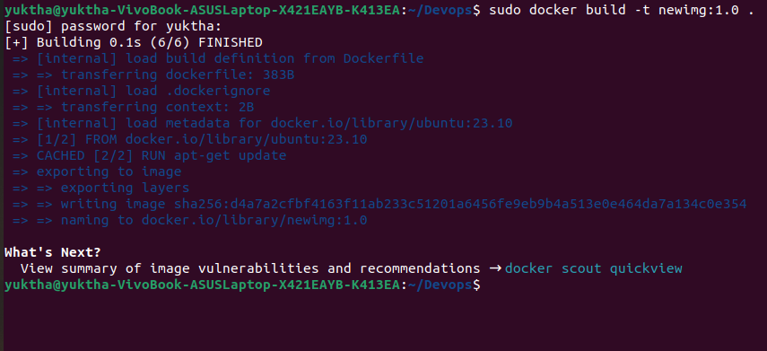

Step 3: Run as Container.

Command: $ sudo docker run -d <imgname>:<tagname>

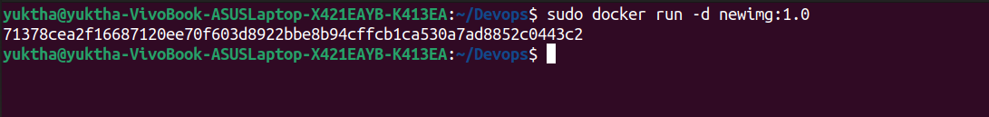
To verify, list the containers using the command: $ sudo docker ps -a

